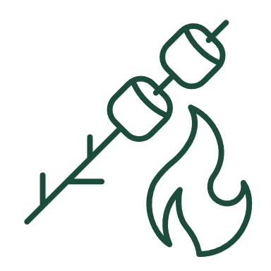

|  |
| --- |
| Camping checklist Use this checklist to gather essential and recreational items to prepare for your upcoming camping trip. After each item is packed, check the corresponding item’s box on this sheet to keep track. |

|  |  |  |  |  |  |
| --- | --- | --- | --- | --- | --- |
| SHELTER & BEDDING | | | | | |
|  | | | | | |
|  | Tent with fly sheet, poles, hangers, stakes |  |  | Sleeping pad, mats, air mattress, air pump |
|  | Tarp |  |  | Blanket, comforter, or sleeping bag |
|  | Rope |  |  | Pillows |
|  |  |  |  |  |

|  |  |  |  |  |  |
| --- | --- | --- | --- | --- | --- |
| COOKING & DINING | | | | | |
|  |  |  |  |  |
|  | Pots and pans |  |  | Paper plates and bowls, plastic ware |
|  | Cutting board |  |  | Tablecloth |
|  | Corkscrew |  |  | Folding chairs and table |
|  | Can opener |  |  | Trash bags |
|  | Multitool or pocketknife |  |  | Camp stove / smoker / Dutch oven |
|  | Mixing bowls and screen covers |  |  | Fuel |
|  | Empty food containers |  |  | Lighter |
|  | Aluminum foil |  |  | Fire extinguisher |
|  | Zip lock bags |  |  | Campfire permit |
|  | Coolers |  |  |  |
|  |  |  |  |  |
| FOOD | | | | | |
|  | | | | | |
|  | Oatmeal |  |  | Butter |
|  | Bread |  |  | Pancake mix |
|  | Soup |  |  | Maple syrup |
|  | Canned tuna |  |  | Juice and milk |
|  | Canned fruit |  |  | Cheese |
|  | Coffee and tea |  |  | Fruit and vegetables |
|  | Peanut butter |  |  | Cooking oil |
|  | Macaroni and cheese |  |  | Salt, pepper, herbs, spices |
|  | Hot dogs |  |  | Water and water purifier |

|  |  |  |  |  |  |  |  |  |
| --- | --- | --- | --- | --- | --- | --- | --- | --- |
| CLOTHING & LAUNDRY | | | | | | | | |
|  | | | | | | | | |
|  | | T-shirts | |  | |  | | Swimsuit | |
|  | | Shorts, pants | |  | |  | | Towels, washcloths | |
|  | | Boots, shoes, flip-flops | |  | |  | | Club soda to rinse out stains | |
|  | | Socks | |  | |  | | Laundry bags | |
|  | | Hat, cap | |  | |  | | Travel-size packets of laundry soap | |
|  | | Neck gaiter/buff, scarf | |  | |  | |  | |
|  | | Underwear | |  | |  | |  | |
|  | | | | | | | | |
| FIRST AID & HYGIENE | | | | | | | | |
|  | | | | | | | | |
|  | Medication, prescriptions | |  | |  | | Bug spray | |
|  | Bandages, tape, gauze, elastic wraps | |  | |  | | Snake bite kit | |
|  | Aspirin, ibuprofen, acetaminophen | |  | |  | | Eye wash | |
|  | Antibiotic wipes, hydrogen peroxide, cotton balls | |  | |  | | Toilet paper | |
|  | Antiseptic cream | |  | |  | | Bar of soap | |
|  | Sunscreen, sunburn lotion or ointment | |  | |  | | Shampoo, conditioner | |
|  | Scissors, tweezers, nail clippers, razor | |  | |  | |  | |